Queries :

Public: The access level of a public modifier is everywhere. It can be accessed from within the class, outside the class, within the package and outside the package.

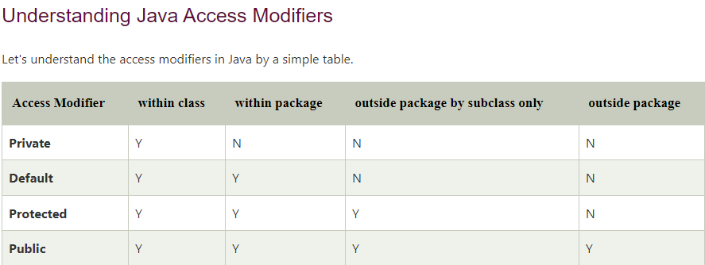

* **Access Modifiers** - controls the access level
* **Non-Access Modifiers** - do not control access level, but provides other functionality

**Non-Access Modifiers**

Java Arrays

Arrays are used to store multiple values in a single variable, instead of declaring separate variables for each value.

To declare an array, define the variable type with **square brackets**:

String[] cars;

String[] cars = {"Volvo", "BMW", "Ford", "Mazda"};

int[] myNum = {10, 20, 30, 40};

String[] cars = {"Volvo", "BMW", "Ford", "Mazda"};

System.out.println(cars[0]);

// Outputs Volvo

public class Main {

public static void main(String[] args) {

String[] cars = {"Volvo", "BMW", "Ford", "Mazda"};

System.out.println(cars[0]);

}

## Change an Array Element

To change the value of a specific element, refer to the index number:

}

String[] cars = {"Volvo", "BMW", "Ford", "Mazda"};

cars[0] = "Opel";

System.out.println(cars[0]);

// Now outputs Opel instead of Volvo

## Array Length

To find out how many elements an array has, use the length property:

String[] cars = {"Volvo", "BMW", "Ford", "Mazda"};

System.out.println(cars.length);

// Outputs 4

## Loop Through an Array

You can loop through the array elements with the for loop, and use the length property to specify how many times the loop should run.

The following example outputs all elements in the **cars** array:

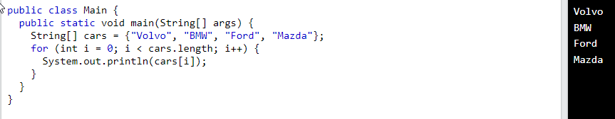

**for each** String element (called **i** - as in **i**ndex) in **cars**, print out the value of**i**.

If you compare the for loop and **for-each** loop, you will see that the **for-each** method is easier to write, it does not require a counter (using the length property), and it is more readable.

public class Main {

public static void main(String[] args) {

String[] cars = {"Volvo", "BMW", "Ford", "Mazda"};

**for (String i : cars) {**

**System.out.println(i);**

**}**

}

}

## Multidimensional Arrays

A multidimensional array is an array of arrays.

Multidimensional arrays are useful when you want to store data as a tabular form, like a table with rows and columns.

To create a two-dimensional array, add each array within its own set of **curly braces**:

int[][] myNumbers = { {1, 2, 3, 4}, {5, 6, 7} };

**myNumbers** is now an array with two arrays as its elements.